**P2 - Explain the user side and server side factors that influence the performance of a website**

**Introduction**

In this report, I will explain the user side and server side factor that influences the performance the performance of a website.

**User side factors**

**Download speed**

Download speed refers to how long it takes a file to be downloaded from a remote source. If I were to download a video from the Internet, I would have to wait for it to be complete. This “wait” refers to the download speed. If the file were large, it would take a long time to complete. Most download speeds are measured in kb/s. If I were to test my download speed, it would show how much megabits per second is. An example below shows how it is.

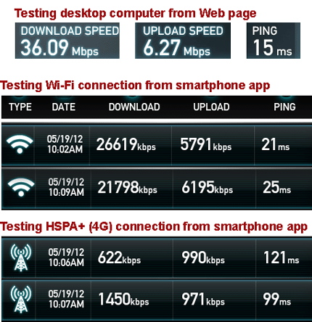

**PC performance factors**

The factors that the PC faces is it becoming slow. This is because if I were to download a large file and open other applications with it, the effect of it is that the RAM not being big enough will not be able to take the applications being open. Therefore, this will result in the computer crashing.

**Cache**

[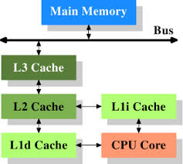](http://www.google.co.uk/url?sa=i&rct=j&q=&esrc=s&source=images&cd=&cad=rja&uact=8&ved=0CAcQjRw&url=http://lwn.net/Articles/252125/&ei=WMpgVNz3O7OKsQSX4oF4&bvm=bv.79189006,d.ZGU&psig=AFQjCNH5aVgkPLaBA5JB3gkkZvBzePOm8A&ust=1415715794084888)A cache is a content that enables the request of the specific site to be located faster. It gets saved, but the computer does not know. This is to improve the input/output of the system. All these saved cache can be cleared, but when the I/O is requested, it will be slow.

**How it works?**

Referring to the image, each cache has different levels. Most computers uses L1 and L2, but nowadays, they use L3 as well. This is very important part as the data is thrown around from then CPU to the memory bus. This also can be cleared by going on ‘Options 🡪 CTRL+SHIFT+DELETE’.

**Server side factors**

**Web server capacity**

A web server capacity is the size of the web server. The capacity of a web server of the web server does not need a separate storage device. It depends on the system unit.

**Web Server**

A web server processes requests via HTTP. This term can be referred to the whole server, or specifically to a software that accepts and supervises the HTTP requests. HTTP is a protocol that uses logical links to exchange or transfer information between nodes. The web server uses this, and any requests made, the web server gets involved. They are different types of web servers that are run, and some of them are the following: gaming, data storage, hosting websites, and many others. These use the process of requesting via HTTP. For example, gaming server. This uses web server, because they need to communicate online with other gamers. This uses the web server to make any requests to the other user. If one user wants to send a message to the other person, it would use the web server to send the message.

***Client side scripting: executions to be performed before page load***

When is a factor that is effected when the page is responded by the web page that has been loaded before, load quicker once it has been typed again. This uses the cache system. If the cache is cleared, it will be slow to load depending on the internet connection.

**Number of hits**

A hit is referred to as request send to the web server. One hit is just the user sending one request to the web server and the web server sending one ‘hit’ back, as explained below.

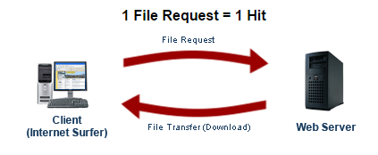

This means when the user sends one request and it sends more than one back. This works by the web page containing more than one file within it. An example could be a website using five icons, it would generate more than 5 hits.

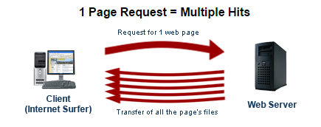

**Graphic Images**

**Vector Graphics**

Figure 1.1

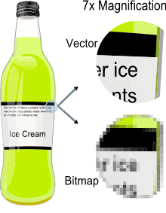Vector is a graphic computer image that it is a scale of quality when it has been enlarged. When it is enlarged, users are focused on the vectors of the image e.g. paths, strokes. It does not lose quality when the image has been enlarged. Referring to the figure 1.1, it shows when you enlarge the image of the bottle. Vector images come out clear whereas Bitmap images does not become clear when it is enlarged. Comparing vector images to ‘JPEG’, ‘GIFs’ and ‘BMP’, it does not contain grid pixels, but it can be different as paths, strokes and curves.

**Bitmap graphics**

As said before, bitmap is a graphic compute image that uses pixels (tiny blocks), because when the image is enlarged, unlike vector graphics, it loses quality. Bitmap graphics can be used on where pixel display is common e.g. CCTV cameras. It is not HD quality, but has pixels like bitmap to be used to create a bitmap display. Referring to figure 1.1, it demonstrates how bitmap image looks like. When it is enlarged, it shows us the pixels. Unlike bitmap, vector images are clear.

**File Size**

File size depends on which format it is used. Each different format differs from each format. As you can see below, this illustrates the different file size and some examples of it. However, the quality matters for each of the files. Also, it differs from each other e.g. 100% would be 446KB; 90% would be 216KB. As you can see the pattern, it decreases each time the quality loses. The higher the quality, the more the file size would be.

|  |  |  |  |  |
| --- | --- | --- | --- | --- |
| **BMP** | **GIF** | **JPG** | **PNG** | **TIF** |
| 2305KB | 209KB | 445KB | 375KB | 2039KB |
| **100%** | **90%** | **80%** | **70%** | **60%** |
| 446KB | 216KB | 203KB | 175KB | 116KB |

**File Format** e.g. JPG, BMP

A file format is a standard code that is encoded for storage in a computer file. Each standard code are different to each other such as BMP, GIF. They are completely different from each other and have different storage available. They are many file formats and the image below shows how many they could be. They could be more but these are a few.

**Sound file types** e.g. wav, mp3

Sound file types is a file type that is used to store audio. The types that I will refer to is WAV and MP3. They are stored differently. Waveform Audio File Format that is used on Windows. This typically stores uncompressed audios. This is a lossless compression. However, other compression types, i.e. Lossy, is MP3. The picture below shows the difference between the two.

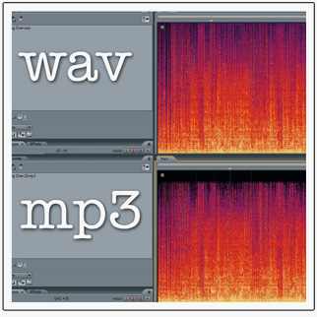

**Video and animation files** e.g. avi, swf

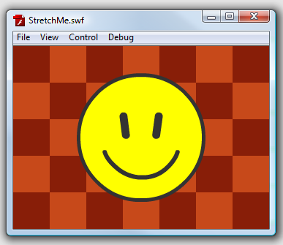AVI stands for Audio Video Interleave. It is a popular file format use for Windows. It is used for Video files only. For AVI, it is used for applications such as Windows Movie Maker. For animation files, SWF is used. SWF stands for small web format. This is used for Adobe Flash File where animation content is created and SWF file format is used.

